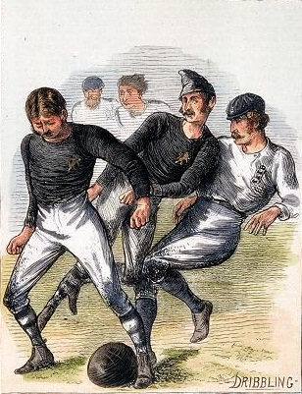Football in History

The Forest Club (Leytonstone)

David Ian Chapman

A short history of

The Forest Foot-Ball Club

(Leytonstone)

**By David Ian Chapman**

**Leyton & Leytonstone Historical Society**

**2016**

First published in July 2016 by

Leyton & Leytonstone Historical Society

27 The Croft

Friday Hill

Chingford

London

E4 6EZ

Website: [www.leytonhistorysociety.org.uk](http://www.leytonhistorysociety.org.uk)

Author’s Note: The modern photographs are taken by the author. The historic photographs are all in the public domain.

ISBN : 978-0-9932736-6-7

The Forest Club (Leytonstone)

Anyone who may have been sauntering along the Whipps Cross Road one Saturday afternoon during the winter months around one hundred and fifty years ago may have seen something unusual. In fact you would have had to have attended public school to just have any idea of what on earth was going on at all. There would be several piles of clothes and a group of well-to-do fellows kicking a ball about, some trying to kick or hack someone else in shins whilst others doing their best to avoid a nasty injury. You would have reported back about seeing mayhem near the Hollow Ponds.

Today we would have believed that we were watching a rough game of rugby. It involved charging, handling and touch-downs much the same as in modern day rugby, except this was a real hooligans’ game played by gentlemen.

The year may have been 1859, but this is in some doubt. Everything points to the club being founded two years later, in 1861, when the club drew up its own first ‘set of rules’. They were based loosely on those drawn up at Cambridge University of circa 1858:

*This club shall be called the University Foot Ball Club.*

*At the commencement of the play, the ball shall be kicked off from the middle of the ground: after every goal there shall be a kick-off in the same way or manner.*

*After a goal, the losing side shall kick off; the sides changing goals, unless a previous arrangement be made to the contrary.*

*The ball is out when it has passed the line of the flag-posts on either side of the ground, in which case it shall be thrown in straight.*

*The ball is behind when it has passed the goal on either side of it.*

*When the ball is behind it shall be brought forward at the place where it left the ground, not more than ten paces, and kicked off.*

*Goal is when the ball is kicked through the flag-posts and under the string.*

*When a player catches the ball directly from the foot, he may kick it as he can without running with it. In no other case may the ball be touched with the hands, except to stop it.*

*If the ball has passed a player, and has come from the direction of his own goal, he may not touch it till the other side have kicked it, unless there are more than three of the other side before him. No player is allowed to loiter between the ball and the adversaries' goal.*

*In no case is holding a player, pushing with the hands, or tripping up allowed. Any player may prevent another from getting to the ball by any means consistent with this rule.*

*Every match shall be decided by a majority of goals.[1]*

But Forest added a few of their own:

*That captains be chosen at the commencement of play, who shall have the direction of places, etc., etc., throughout the game.*

*That the length and breadth of ground be marked off with flags, and that the distance between the goal-posts do not exceed eight yards.*

*That in the event of the bursting of the ball, a new one is to be placed at the centre of the ground, and that the side commencing the game have the kick-ff.*

*That for any wilful infringement of* *the rules of the game, a fine of Two Shillings and Sixpence be inflicted.[2]*

The Forest clubs’ origins had been printed by Charles Alcock in *The Book of Football,* 1906.

*that the first club to work on a definite basis with the distinct object of circulating and popularising the game . . . was a club known as the Forest Club. Founded in 1859, by a group of old Harrovians under the captaincy of J F Alcock, the Forest Club used a pitch in Epping Forest – near the Merchant Seamen’s Orphan Asylum at Snaresbrook[3].*

This comment has been picked up and repeated *ad infinitum* by all and sundry. The fact that Charles Alcock, the elder brother of John Alcock should have known what he had written is undermined by the omission of any mention of the Sheffield Club. Alcock also claimed that another neighbouring club, in this case Leyton, had been founded two years earlier than any supporting evidence. Fortunately, we do have evidence from Alfred Mackenzie, the Forest Club’s secretary writing in 1909:

*Afterwards we lived at Woodford, and my connection with Leytonstone was confined to a couple of matters. One of them was playing football in front of Forest-Place (also called Assembly Row), where I was the first secretary of the ‘Forest Football Club,’ founded in 1861, well known in its day, and had the honour of calling the meeting at the Freemasons Tavern in October 1863, at which the ‘Football Association’ was founded. The Football Association may, therefore, be fairly said to have been cradled in Leytonstone, if not born there.[4]*

Neither were all the early members of the Forest Club Old Harrovians. **Alfred Westwood Mackenzie** (24th May 1840 – 6th April 1924) was born in a house on the corner of Leytonstone High Road and Browning Road. His parents were the surgeon, Stephen Mackenzie, and Margaret Frances Harvey. Two of Alfred’s three brothers followed their father into the medical profession. His elder brother, Morell Mackenzie famously attended the German Crown Prince for throat cancer. He may have mis-diagnosed fully the condition with inevitable results for which he was castigated. He had been knighted in 1887, but in less than a year the Crown Prince, now Kaiser, was dead. His younger brother, Stephen Mackenzie, became a physician and lecturer at the (Royal) London Hospital, and was knighted in 1909. Alfred took his unusual middle name from another surgeon and family friend, Alfred Westwood, who lodged with the Mackenzies. Alfred was educated at Walthamstow House in Wood Street. He became a manager for the Guardian Fire and Life Assurance Company of Lombard Street, City of London.

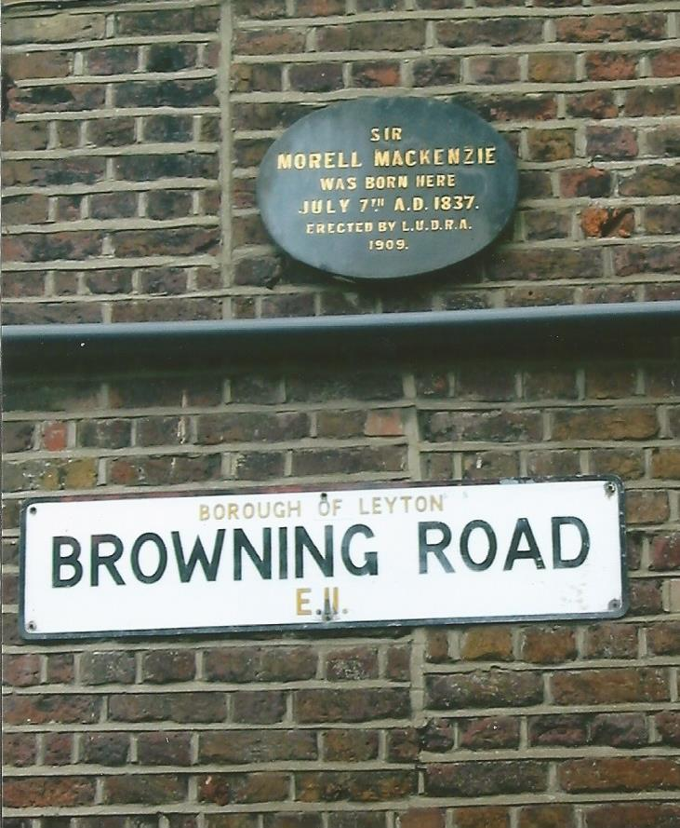The Leyton Urban District Ratepayers Association erected a plaque to Sir Morell Mackenzie, which was also the birthplace of Alfred Mackenzie, in Browning Road. The plaque was unveiled in 1909.

Located on the south side of Whipps Cross Road are a row of Georgian houses, originally twelve in number, now reduced, which were built in 1767. Known as Assembly Row, and taking its name from the now demolished Assembly House, and later named Forest Place. It is my belief that some members of the Forest Club attended a boarding school here. It would certainly makes sense for the footballers to change at the school and cross the road to the flat ground opposite. It would also appear that the club probably took its name from Forest Place.

There is further evidence from a match report in the Forest School Magazine of a match between the school and Tottenham and Edmonton in October 1866:

*On account of bad weather the game took place at Forest Place instead of on the school ground*.[5]



The above advertisement appeared in Bell’s Life in London and Sporting Chronicle for 7th September 1862.

The truly first local newspapers did not begin to appear until 1870 so any reports of the growth of the Forest Club have to be gleaned from national papers. The first report of any match involving the Forest Club comes from Bell’s Life in London and Sporting Chronicle in March 1862.

*THE FOREST CLUB V THE CRYSTAL PALACE CLUB*

*This match came off on Saturday, the 15th inst. on the ground of the former club at Leytonstone, Essex. Play began at about half-past two, and ended at five p.m. The result was a victory for the Forest Club, who obtained one goal, their opponents having got none. The play on both sides was acknowledged to be very good, and that the game was hardly fought is shown by the fact that the only goal won was obtained after an hour and a half’s play.*

*The Forest: Messrs J F Alcock, C W Alcock, H Bigland, C Bigland, C Jackson, A W Mackenzie, J Morgan, J Pardoe, J Robertson, C Tebbutt, A Tebbutt, M Saville, J E White, & W F Woodward.*

*Crystal Palace: Messrs Allport, Bell, Cutbill, Day, Head, Jackson, R Lloyd, Lloyd, Lloyd, Medwin, Phelps, Sharland, Turner & Urwick.[6]*

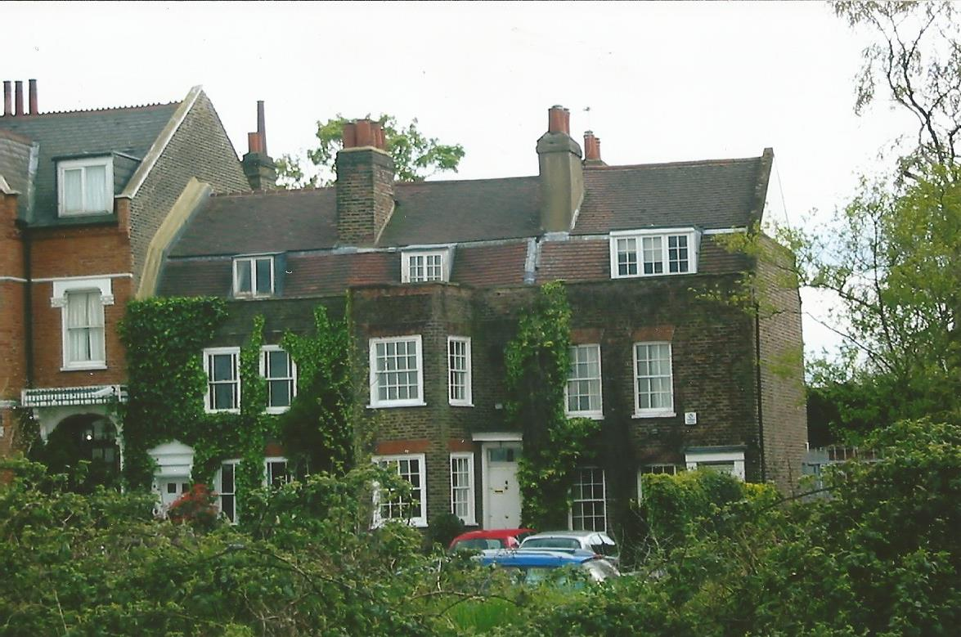

Forest Place 2016

Both sides fielded fourteen players. Forest was captained by **John Forster Alcock** (14th April 1841 – 13th March 1910), a Geordie from Sunderland born to parents Charles Alcock and Elizabeth Forster. His father was a ship owner. The family moved to Chingford and lived at Sunnyside at the top of Kings Head Hill. John went Harrow School in January 1855, where later the same year he was joined by his brother, **Charles William Alcock** (2nd December 1842 – 26th February 1907). After leaving Harrow School John became a ship broker. Although it was John who was a prime mover in the establishment of the Football Association, he was to be eclipsed by his younger brother.

**Charles William Alcock**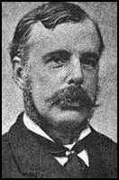

On Monday 26th October 1863, John Alcock and Alfred Mackenzie attended a meeting held at the Freemasons’ Tavern[7], Great Queen Street in London with ‘like-minded’ representatives of the leading football clubs in the south. The clubs who sent a representative were : Barnes, War Office, Crusaders, Forest (Leytonstone), No Names (Kilburn), the original Crystal Palace, Blackheath, Kensington School, Perceval House (Blackheath), Surbiton, Blackheath Proprietary School and Charterhouse. The main aims in forming an association were formulate a set of rules for playing the game upon which they could all agree. It is well-known that the one important question was over “hacking”, which most wanted prohibited. Blackheath felt so strongly that they refused to join and eventually formed what became the Code of Rugby. In time rugby players would also come to outlaw “hacking”. It took a number of meetings before it was settled on using the Cambridge rules. Just as a universal agreement was reached the Forest Club were to fade into oblivion[8].

John served as an FA committee member until 1866 when he was replaced by his brother Charles. Charles Alcock went on to become the secretary of the FA in 1870. With the advent of professionalism in football, Charles was now the first professional at the FA, a position he held until 1895 when he retired and was appointed Vice-President. As a player he represented London against Sheffield in 1866 and England against Scotland in 1875. Outside of football Charles was secretary of the Surrey County Cricket Club.

In total there were three sets of brothers in that first Forest team. The second pair of brothers comprised **Samuel Henry Bigland** (1841 - 1929) who was born on Merseyside in Liverpool to a Quaker family, and his younger brother, **Compton Bigland** (10th June 1844 - 1873) a commercial clerk until his early death in March 1873. The Biglands moved to Walthamstow, living in Salters Buildings at Whipps Cross, from where Samuel became a marine insurance broker and later a journalist.

On the 1871 census we find Compton Bigland staying with his sister, Emily, and her husband David Morgan at 6 Grove Road, Wanstead. Also lodging with them is Charles Tebbut.

In Davis Lane, off Leytonstone High Road, stood the Cedars, a nice house standing in large grounds with two large cedar trees, and occupied by a Captain Tebbut. Captain Charles Tebbut was a ship builder, with a ship repairing yard in Limehouse. He had two sons, **Charles Mansfield Tebbut** (24th December 1839 – 27th September 1898) and **Arthur Marshall Tebbut** (4th February 1841 - ?). Charles followed his father in shipping. Arthur became a ships captain with the reserve force and sadly died abroad at Buenos Aires. Both brothers were keen sportsmen and played cricket, Charles at county level with Middlesex, and Arthur with Shropshire. Charles was also a long standing committee member of the Middlesex County Cricket Club at one time becoming treasurer. He died of apoplexy in 1898.

**David** **John** **Morgan** (25th April 1844 – 28th February 1917) was born in the family home, the White House in Leytonstone High Road close to the Cedars. He was educated at the nearby Forest School and finished his education in Vevey, Switzerland. Morgan was involved in shipping as a Russian merchant and a director of the Surrey Commercial Docks. On 20th February 1867 he married Emily Bigland, the sister of two of his team mates. He became a county councillor in 1889 and at the turn of the century he entered parliament as a Conservative, winning the seat of Walthamstow.

From nearby Woodford came **Cowper Donne Jackson** (1839 – 1900) who had been born in Blackheath, a strong rugger part of London. He became a mechanical engineer and was accepted as a Freemason in 1865. A few years later he was married by consent of the British Ambassador in the British Embassy in Paris.

From 1848 until 1873 the vicar of Leyton had been the Reverend John Pardoe. His son, also **John Pardoe** (1839 – 23rd April 1892) was another old Harrovian, later of Trinity College, Cambridge. He became the rector of Graveley in Hertfordshire, where he died in 1898.

The last player who can be identified with all certainty is **Frederick W Woodward** (1845 - ?). Born in Wednesbury, Staffordshire, Woodward became a boarder at Samuel Winter’s, a military tutor, in Woodford during the eighteen sixties. He played in the first few games then faded from the scene.

Three weeks after the game against Crystal Palace the two clubs met again, this time near Penge Common. The Palace are said to have been formed by a group of workmen at the original Crystal Palace, built for the Great Exhibition of 1851 on Sydenham Hill.

*FOOTBALL AT THE CRYSTAL PALACE*

*FOREST CLUB v THE CRYSTAL PALACE CLUB*

*The return match between these two clubs came off on Saturday week, on the ground of the latter, at the Palace. The weather, which had been fine for the previous two or three days, was again wet, and the ground was not in first-rate condition. Despite drawbacks, however, play commenced at three o’clock, and continued until five. The result was another victory for the Forest Club, for at the conclusion of the game they had obtained four goals, their adversaries none. Three of these were kicked by Mr Pardoe, and the other by Mr C Bigland. The play on both sides was good, but it was evident that the Forest Club were decidedly superior to their opponents, who admitted that they (the Forest Club) had it all their own way. The players were*

*The Forest: Messrs J F Alcock, C W Alcock, H Bigland, C Bigland, A J Barnes, F W Connery, C D Jackson, D J Morgan, J Pardoe, J Robertson, W J B Standidge, C M Tebbut, A M Tebbut, W F Woodward & A W Mackenzie.*

*Crystal Palace: Messrs W Allport, F Bevington, W Cutbill, E Cutbill, F Day, T Jackson, T Lloyd, H Lloyd, H Lloyd jnr, W Noakes, Sharland, J Turner, T Unwick, H Wood & A Wood.[9]*

New to the Forest club was **William John Burford Standidge** (27th August 1831 – 1901). Standidge was baptised in Old St Pancras Church on 23rd September 1831. Around the time of the game he was a lieutenant in the Royal South Middlesex Militia and living with his widowed mother at Debden Green. He died and was buried at Chigwell in 1901.

Matches were few and far between in those early days. The team they may have met would have been Forest School. Here unfortunately there are no school records before September 1864. As far as we know the new season, 1862/3, opened in February with a visit to west London to meet the Barnes Football Club.

*BARNES v FOREST*

*A match between these clubs (twelve on each side) was played at Barnes on Saturday, and was one of the finest we have ever seen. The play on each side was so admirable that both deserved to win, but fortune favoured the Forest Club who after an hour and a half’s most spirited play won a goal. The ball had for some time shown an anxiety to claim acquaintance with the Forest goal, when suddenly it was run down to the Barnes goal, and a scrimmage took place in which the ball was kicked into the air, and dropped onto the goal post and, although touched by the goal-keeper, slipped in. Goals were then changed and the game was hotly contested until the time approached for the cessation of hostilies (5.30), when the belligerents reluctantly drew their forces without either party made another goal. The play lasted altogether two hours and a*

*half.[10]*

Although not mentioned in the report the goal was credited to Charles Alcock.

Three weeks later the two clubs met again on the Forest ground. There is no report extant, just the final score which was the same as the earlier game and again Charles Alcock was on the score sheet. A week later the ‘old enemies’, Crystal Place visited Leytonstone:

*FOOTBALL - FOREST CLUB v THE CRYSTAL PALACE CLUB*

*The return match between these clubs came off on Saturday, March 21, on the grounds of the Forest Club. Play commenced at half-past three. The first goal was obtained by the Crystal Palace club, at about five o’clock. The Forest Club were now getting warm into play, and succeeded during the remaining half-hour – it having been arranged that time should be called at half-past five – in obtaining two goals, both of which were kicked by Mr C Alcock. The final rush of this gentleman for the last goal was really magnificent, and won great applause. The Forest Club closes for the season, on Saturday, the 4th inst. It has been very successful during the present season, having suffered no defeat in any of its matches.[11]*

Who the mystery opponents were for the last match of the season is not known as the game has not been covered in the national press.

Following the inagural meeting, in October 1863, from the representatives of about a dozen clubs it was proposed by Ebenezer Cobb of the Barnes Club that they should form an ‘Association’ and that a set of rules by which they could all compete could be agreed. This motion was seconded by Alfred Mackenzie, who also suggested that a set of officers be appointed. It was at a subsequent meeting of the Football Association that John Alcock suggested adhering to the rules as played at Cambridge, which Forest were already using. This was agreed except there was strong feeling over the question of ‘hacking’. John Alcock suggested that as it was getting late this should by covered in a further meeting. At a fourth meeting once again John Alcock pressed for an agreement on the use of the Cambridge rules. There was still a determination from Blackheath for the retention of allowing anyone running with the ball to be tackled or ‘hacked’. It will be noticable that both Alfred Mackenzie and John Alcock were the ones making the running.

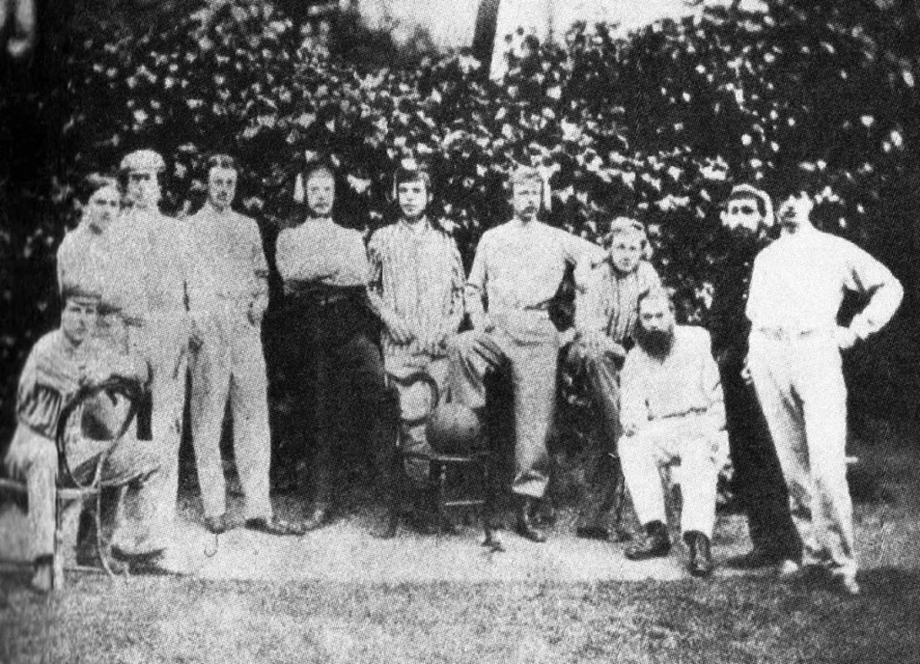

Forest Foot-Ball Club c1863

Left to right: J Pardoe, F C Adams, R Edmunds, C Bigland, J F Alcock,

C W Alcock, C D Jackson, C M Tebbut, W B Standidge, A M Tebbut

& A L Cutbill.

A new season and new opponents when the Forest Club visited the Richmond club:

*FOREST (LEYTONSTONE) v RICHMOND*

*These clubs met on Saturday last, Nov 7, and, despite the bad weather, nine assembled on each side. The match was played on Richmond Green and resulted in an easy victory for the F. F. C., who obtained three goals, their adversaries getting none. Messrs Pardoe, Morgan and Jackson were the players who showed their skill and prowess in kicking these goals, and the others all worked well and assisted in the triumph. Mr Hodgson, on the part of Richmond struggled most valiantly to stem the tide, but without the success his efforts deserved.[12]*

A week later and Forest were back in west London visiting Barnes.

*FOREST CLUB v BARNES*

*This game was played on Saturday, Nov 14, on the ground of the latter. The two elevens commenced the match about three, and before the time for concluding (five p.m.), no less than 5 goals had been kicked. These were all obtained by the F. F. C. who thus proved themselves to be the victors. The players who distinguished themselves in getting the goals were Messrs C W Alcock two, and Pardoe, Morgan, and Adams, one each. A large number of spectators were present.[13]*

The following Saturday and Richmond made the long trek across London, which must have felt a lot further going back:

*FOREST CLUB v RICHMOND*

*The return match between these clubs came off on Saturday, Nov 21, on the ground of the Forest players at Leytonstone, and it being the first match this season that the F. F. C. had played upon their own ground, attracted a large number of spectators. Play began at half-past two with 10 on each side, and at four o’clock the number of goals obtained by the Forest being 5, and the Richmond none, they broke off. These were kicked by Messrs, J F Alcock 2, C W Alcock, C and A Tebbut. A scratch game brought the afternoon to a pleasant conclusion.[14]*

What we assume was breaking new ground was when the visitors were the mysteriously named N. N. (Kilburn). Some think it stood for ‘No Name’ which is as good a guess as any. You would have thought though that the recently elected President of the Football Association (Arthur Pember) could have come up with something better.

*FOREST CLUB v N N (KILBURN)*

*A game was played between these clubs on Saturday, Nov 28, at Leytonstone. Shortly after two the two sides tossed up for goals. The game was a very* *interesting one, and resulted in a victory for the Forest, who obtained 4 goals, their adversaries gaining a ‘blank’. Messrs J F Alcock (2), Cotton and Absolom got the goal for the F. C., and Mr Giles of the N. N. did good service for his side. Thirteen on a side played, although it had been arranged that fifteen should be the number. A large number of spectators were on the ground, and showed by their applause a keen appreciation of the play.[15]*

Two new names appeared for the Forest side. Cotton or it could be Colton and **Charles Alfred Absolom** (7th June 1846 – 30th uly 1889). Absolom had been born in Blackheath, the same location as Cowper Jackson. He attended school at Calne in Wiltshire and Trinity College, Cambridge, as did John Pardoe. Their ages suggest that the latter did not meet at university, where he gained his ‘Blue’ at both atheltics and cricket at which he excelled. Absolom played for Kent and for his country against Australia, during the tour led by Lord Harris. He died at the age of forty-three at Port-of-Spain in Trinidad. He has been described by Benny Green as a ‘gentle giant’ who picked up the nickname of ‘The Navvy’, whilst at Trinity. Strangely little is known of his later life. His death came as a result of an accident when acting as a purser on a ship carrying bananas and the load slipped from the crane and fell on him, injuring him so severely that he died a few days later.[16]

After a break of a week old friends in Barnes were the next visitors as reported in Bell’s Life.[17]

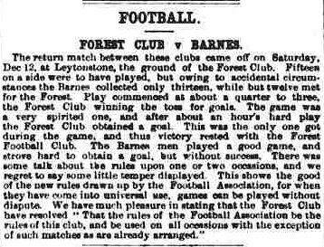

Mention of a disagreement about the rules would soon be a thing of the past. Both John Alcock and Alfred Mackenzie had strived long and hard to get an agreement with their other colleagues in the recently formed Football Association. In the last two F A meetings, held prior to this last match, feelings came to the fore and finally Blackheath was defeated over the question of ‘hacking’.

*FOREST CLUB v THOMPSON’S XI*

*Eleven members of the Forest Club met Thompson’s Eleven on Saturday, Dec 19, at Leytonstone, for a friendly game. The afternoon was fine and the game one of the most spirited and exciting of the season. At the conclusion of the match the F. F. C. had obtained 4 goals and their adversaries none. These were got by Messrs C Absolom, C Adams and C Alcock, the first obtaining 2. Where all did their best it would be invidious to mention names, but the spectators, of whom there were a goodly array, justly acknowledged it to be the finest match played by the Forest Club in six weeks, all of which they have won. It is a remarkable thing that in these matches the F. F. C. Have obtained 22 goals and their various opponents not one. The players on Saturday were:-*

*Forest: Messrs J F Alcock (capt), C W Alcock, F C Adams, C Absolom, H Head, H Bigland, C D Jackson, H S Jackson, J Pardoe, B D Tabor, C M Tebbut, and A M Tebbut.*

*Thompson’s XI: Messrs F W Greaves (capt), F C Back, E W Burnett, L O, Deaborough, A K Finlay, C C Finaly, E G Greenhill, F Lucas, A Thompson, W J Thompson, and C Wright.*

*LAWS OF THE GAME – The new laws, as decided on at a meeting of the Football Association held at Freemason’s Tavern Dec 8, have been published in convenient pocket form by John Lillywhite, Seymour Street, Euston Square. The same rules, on a roller sheet , will shortly be issued for the use of club rooms.[18]*

Of the two new names, one was that of **Harvey Seymour Jackson** (1841 – 1911) the younger brother of Cowper Jackson. Harvey, like his brother, had been born south of the river in Blackheath. He became a commercial shipping clerk whilst joining the services as an ensign in the 24th Essex Rifle Volunteers.

The second newcomer was **Benjamin Dixon Tabor** (17th August 1842 – 2nd March 1907). Born in rural Essex at Bocking and by the time of the 1861 National Census he was living in Islington. Benjamin began a clerk in a Spanish merchants office. Twenty years on and he had done well for himself as he was now described as a merchant and banker, of Gracechurch Street, in the City of London, and living in Fairmile Cottage, Cobham. He died, unmarried, on 2nd March 1907 and left a considerable sum of well into six figures.

Another new year and with hindsight there was a hint that things were going to change shortly. Whereas the reporting had been regular, the next three games all appeared in a composite report in Bells Life for the end of February.

*THE FOREST CLUB*

*This club has lately had its hands, or rather, perhaps, we should say its feet, full of work. It has played three matches in the last four weeks, and has fully sustained its reputation of never having suffered a defeat. The first of these matches was played on Saturday, Jan 23 on the clubs ground at Leytonstone against 15 of King’s College, and resulted in an easy victory for the Forest, who obtained two goals to their adversaries none. These were got by Messrs Absolom and C Tebbut. This being the first match since Christmas, a large number of spectators assembled, and warmly congratulated the members of the F. F. C. on keeping their fame untarnished.[19]*

One thing that is not explained is how, with no local newspapers, did the spectators know there was a match on? Did they just turn up in the hope of seeing a game? It remains a mystery.

*The second match came off on Saturday, Feb 6, at Harrow, and was against Harrow School. It had been agreed that play should commence about two and continue till quarter to four, 11 being on each side. Owing to some slight misunderstanding as to the time, it was half past two before the two sides got into working order, but when they did set to work, spirited indeed was the way in which it was kept up. Many of the F. F. C. expecting some good play, came down to see it, and they were gratified to their utmost, for a more interesting and exciting game we have seldom witnessed. We wish we could say the ground was in as fine a condition as it might have been, but to speak the strict truth it could hardly have been worse, and the large amount of mud that attached itself to the boots of the players seriously impeded their speed. We doubt if even the great Deerfoot could have gone at anything like his usual pace upon it. Despite the drawbacks, however – despite strange rules, bad and new ground, a well practised and skillful team, the F. F. C. remembered that their co-members “expected every man would do his duty,” and fought a good game, for when time was called neither side had got a goal, and so the game was a drawn one. Both sides played beautifully, and we must be allowed to mention Mr C Alcock of the Forest, and Messrs Phipps of the school, as especially worthy of mention.*

*In the Harrow match the Forest consisted of Messrs J F Alcock (capt), C W Alcock, Adams, Absolom, Burnett, Cotton, Finlay, Greaves, Gillespie, C M Tebbut, and A M Tebbut.*

*The names of the Harrow Eleven we were unable to establish.[20]*

The inclusion of **Theodore Wilson Greaves** (1844 - 27th January 1878) is interesting as he had previously played for Thompson’s Eleven against the Forest Club along with Burnett and Finlay. Greaves was born in Burton upon Trent, but brought up in south London in Tooting. He attended Harrow School before becoming a tea planter in Assam Province. It was here in India that he died at Samagoorie in 1878 at the age of thirty-three.

Another old Harrovian was **Ernest Wildman Burnett** (22nd September 1844 – 22nd December 1931). Born in Brighton, Burnett excelled at both cricket and football. He went on to play cricket for many well-known clubs including I- Zingari and the Free Foresters. He was the owner of a coal masters, iron masters and tool manufacturers in Cannock, Staffordshire. His death came just before Christmas in Oxford in 1931.

The third old Harrovian was **Alexander Kirkman Finlay** (1844 – 29th July 1883), the second son of Alexander Struthers Finlay of Castle Toward in Argyllshire. He was educated at Harrow School and Trinity College, Cambridge, before travelling to Australia. At Glenomiston in Victoria, where his father was a partner in several estates, Finlay took up stock breeding in cattle and sheep. In 1878 he married Nora Robinson, the daughter of the Governor of New South Wales. There were said to be upwards of 10,000 people lining the streets of Sydney on the day of the wedding. Having travelled back to Scotland on account of his health, he died at Castle Toward in 1883.

*The third game was played on Saturday, Feb 13, when Thompson’s Eleven came down to Leytonstone to endeavour to win back the laurels they had lost to the Forest Club, on a former occasion. In spite, however, of all their efforts they were unable to attain the height of their ambitions, for though the result was not so disastrous to them, as before, yet the game was drawn, both sides obtaining two goals. Messrs C Alcock and Pardoe for the Forest and Thompson and Greaves for Thompson’s were the fortunate players who got them. That afternoon was, to say the least of it, wet, and most of the players were fully aware of the “power of rain” before the game was commenced, but they managed by a judicious application of another kind of wet to keep their spirits up for the encounter. The play of Messrs Greaves and Burnett for Thompson’s and Messrs J F Alcock and Pardoe for the Forest was justly admired. We think it saying a good deal for Thompson’s Eleven when we record the fact that it in no other match have the F. F. C. lost a goal, and it must be a satisfaction to the members of the Forest Club to know that the only adversaries who ever got goals against them were able players and good fellows.*

*In the last match for the Forest club were Messrs J F Alcock (captain), C W Alcock, Absolom, Cotton, Cutbill, Edwards, Gardener, Jackson, Pardoe, C Tebbut, and A Tebbut.*

*Thompson’s Eleven Messrs Burnett, Finlay, Greaves, Harper, R Y Head, Lucas, Melhurst, Reeves, C Wright, F Wright and A Thompson.[21]*

There was a game played at Harrow School on the Thursday 25th February 1864, against a team selected by Theo Greaves. His side included the Alcock brothers, Burnett, Finlay, C Tebbut and Absolom all of whom had played for the Forest Club. The remainder included E E Bowen and A Thompson and with the exception to Tebbut they were all old Harrovians.

The final game involving the Forest Club for this season seems to have been on the 27th February 1864 against N. N. Kilburn and ending in a scoreless draw.

The new season presumably opened with a visit to Penge to challenge the Crystal Palace Club.

*Forest Club v Crystal Palace*

*An exciting match took place last Saturday between these two clubs on the ground of the C. P. F. C., at Penge. Both sides fought hard for victory, but fortune favoured the F. F. C., for whom Mr C W Alcock kicked the goal which won the triumph of the day. For the F. F. C. Mr R Cotton and A Thompson by their forward play, and Messrs J Elliot and C M Tebbut by their fine kicking as first and second goal, did great service to their side. For the Crystal Palace Club Messrs H Lloyd and J Turner played well. The elevens were as follows:*

*F. F. C:* *Absolom*, *C W Alcock, R Cotton, J Elliot, C Hamilton, C D Jackson, C Tebbut, A Tebbut, and A M Thompson.*

*Crystal Palace: D Allport, W Allport, F Collins, A Cutbill, W Cutbill, J Grose, H Lloyd, F Morris, J Rhodes, J Starland, and J Turner.[22]*

Unless there was a bit of misreporting the Forest Club won despite being two men short.

A week later, Forest were away once again this time playing in Battersea Park where their opponents were the Civil Service Club. The Civil Service club were founded back in 1862/3 and is the only remaining club that helped form the Football Association that is still in existence. There was no report, just the record that Cotton scored the only goal of the game.

Forest’s next game is of considerable historic interest. It was played, although no report has been uncovered, on 7th January 1865 at Leytonstone, where their opponents were The Wanderers, somewhat disputing the claims that the Forest Club changed their name and moved away. As their name suggests The Wanderers played on their opponents’ grounds before settling at The Oval. It was at the Oval that Charles Alcock was to become the first professional secretary of the Surrey County Cricket Club.[23]

Despite their believed demise, the Forest Club met their old nemesis in the boys of Harrow School the following week.

*A match was played at Harrow on Jan 14, between Mr Bowen’s homeboarders and the Forest Wetteruns, which resulted in a victory for the Wetteruns by two bases to one. In spite of the unceasing attacks of wind and rain play was kept up with great spirit for an hour and three quarters. The bases for the Wetteruns were kicked by C W Alcock and C M Tebbut. The only base for the Homeboarders by S Thornton.[24]*

There were several more games scheduled for the Forest Club against Crystal Palace, NN Kilburn and the Civil Service for which no reports have been uncovered. It is more than possible that these games did not come off as there is a report of a match against Crystal Palace a month after it was due to be played.

*Crystal Palace v Forest Club*

*A match was played between the Forest and the Crystal Palace Football Club, on the ground of the former at Leytonstone, on Saturday, Feb 25. The F. F. C were victorious by one goal (well kicked by H G Phipps) to their opponents none.*

*On Saturday, March 4, on the the same ground, the F. F. C. played the Walthamstow Club, and were again victorious, scoring four goals to their opponents none. Goals kicked by J Pardoe, A M Tebbut and two by C W Alcock. Mr R Piper was conspicuous for his play on the side of the F. F. C.[25]*

The Forest goal was credited to H G Phipps, who did attend Harrow School. However, I am inclined to believe this was in fact **Henry Hugh Thomas Rose Phipps** (1845 – 19th July 1925). Henry Phipps had been born in St Servan, France c1845 and baptised in 1847, probably by the Rector Richard Greaves at Tooting in south London. At the time of the 1851 national census Hugh and his widowed mother, Rebecca, were living with the Rev and Mrs Greaves along with their son Theodore. Theodore and Henry were then both aged seven years and the boys later attended Harrow School together. Henry went on to Trinity College, Cambridge where he studied law and entered the Inner Temple. Henry married late in life at the age of fifty-seven and died in Fulham in 1925.

Now there was breakup of the Forest Club as the next date for which a report of a match played them is in January 1868.

*Wanderers v Forest Club*

*This match was played on the ground of the latter club, at Woodford, on Saturday last, the 23rd inst, and resulted in a victory for the Wanderers by three goals to none. The weather was favourable, and the ground, thanks to the hard frost of the previous night, was in excellent order for going. The Wanderers won the toss, and gained thereby the advantage of a slight wind and the ball being kicked off by their opponents shortly after half past two o’clock. The Wanderers at once got to work, and soon succeeded in turning their advantage to good account, J M Yates, by a well-directed side kick, securing a goal for them after about 10 minutes’ play. After the change of ends the Wanderers still maintained their superiority, and the ball being judiciously middled from the neighbourhood of touch by C F Read, was again planted between the Woodford posts by T C Hooman. R E L Wade, by a long and somewhat lucky kick, soon afterwards placing the third goal, to the credit of the Rovers. During the latter half of the game the home team were considerably augmented in numbers which enabled them to make a better fight of it, and once or twice the ball was carried within a few yards of the Wanderers goal, though it was not until within a few minutes of time that they were able, owing to the mismanagement one of their opponent’s backs, to score a rather fluky goal. Considering the recent foundation of their club, the Woodford team deserve great credit for the plucky resistance they offered to such skilful adversaries, and with the benefit of wider experience, and more careful attention to accuracy to the long and reckless kicking, they may soon develop into a good working team.*

*Wanderers – J F Alcock, C F Reid, L M Yates, T C Hooman, R E L Wade, F Stileman, A Shaw, Vero Shaw, C James, C Clementson, and F Clementson.*

*Forest Club – L Phillips, B Walters, F Walters, W Bauch, A Bauch, J Towmsend, H Shelton, H W Fry, J Conquest, C Pearson, and R Piper.[26]*

None of the Forest players seem to have ever played for the club before and it was stated in the report that they were recently founded. We can assume that the original Forest Club, the team that were the first to play in London on a more or less regular basis, was now defunct.

The Woodford based football club seems to have carried on for a couple more seasons, although their matches against The Wanderers ceased after the end of 1870/1. One interesting match in which a Forest player appeared was for The World against The Wanderers held at The Oval on 25th March 1871. The Forest player concerned was W R Dent.

The last player worth mentioning is the captain of Forest in the eighteen seventies, **Phillip John Gracchus Rouquette** (25 June 1846 – 7 January 1924). He was born in Clapham and by 1871 he was living at home in Marsh Street, Walthamstow with his recently widowed mother and five siblings. He attended Bradfield College and became a merchant and banker. He was made bankrupt in 1894 and retired to Henley-on-Thames where he died in 1924. Rouquette also captained the Walthamstow club during the same period.

**1861/2**

15 March Crystal Palace @ Leytonstone 1 0

5 April Crystal Palace @ Crystal Palace 4 0

**1862/3**

21 February Barnes @ Barnes 1 0

14 March Barnes @ Leytonstone 1 0

21 March Crystal Palace @ Leytonstone 2 1

? Crystal Palace @ Crystal Palace ?

**1863/4**

7 November Richmond @ Richmond Green 3 0

14 November Barnes @ Barnes 5 0

21 November Richmond @ Leytonstone 5 0

28 November N N (Kilburn) @ Leytonstone 4 0

12 December Barnes @ Leytonstone 1 0

19 December Thompson’s XI @ Leytonstone 4 0

23 January King’s College @ Leytonstone 2 0

6 February Harrow School @ Harrow 0 0

13 February Thompson’s XI @ Leytonstone 2 2

27 February N N (Kilburn) @ Kilburn 0 0

**1864/5**

19 November Crystal Palace @ Penge 1 0

26 November Civil Service @ Battersea Park 1 0

7 January Wanderers @ Leytonstone

14 January Harrow School @ Harrow 2 1

8 January Crystal Palace @ Leytonstone

4 February N N (Kilburn) @ Leytonstone

18 February Civil Service @ Leytonstone

25 February Crystal Palace @ Leytonstone 1 0

4 March Walthamstow @ Leytonstone 4 0

1868/9

23 January Wanderers @ Woodford 0 3

6 March Crystal Palace @George Lane 0 2

27 March Wanderers @ Woodford 0 0

10 April Crystal Palace @ George Lane 0 0

1869/70

9 October Forest School 0 1

30 October Wanderers @ Woodford 0 5

13 November Wasps @ Hampstead

20 November Hampstead Heathens @ Hampstead 1 0

27 November Forest School @ Walthamstow

4 December N. N. @ Kilburn

11 December Walthamstow @Walthamstow 1 0[27]

1 January Woodford Wells @ Woodford 0 0

8 January Clapham Rovers @Woodford

29 January N. N. @ Woodford 1 1

5 February Woodford Wells @Woodford

12 February Hampstead Heathens @ Woodford

26 February Wanderers @ Woodford 0 7

12 March Crystal Palace @ Woodford 0 0

19 March Clapham Rovers @ Clapham 2 1

1870/1

8 October Forest School @ Walthamstow 1 0

11 October Clapham Rovers @ Leytonstone

15 October Clapham Rovers @ Clapham

22 October Mochicans @ Edmonton

29 October Walthamstow @ George Lane

5 November Wanderers (Seconds) @ Woodford 0 2

12 November Hampstead Heathens @ Hampstead 0 0

19 November CCC @ Clapham Draw

26 November Crystal Palace @ George Lane 1 0

3 December Wasps @ George Lane 1 0

10 December Forest School @George Lane

17 December Crystal Palace @ Crystal Palace

24 December Brixton @ Brixton

7 January Wasps @ Hampstead

14 January Hampstead Heathens @ George Lane

21 January Walthamstow @ Walthamstow 0 0[28]

4 February Brixton @ Woodford

11 February CCC @ Woodford 1 0

25 February Clapham Rovers @ Woodford 0 4

18 March Wanderers @ Oval 0 2

1871/2

21 October Upton Park @ Woodford 0 2

28 October Crystal Palace @ Crystal Palace

11 November Forest School @ Forest School 1 0

18 November Law Club 0 3

2 December Clapham Rovers @ Woodford Draw

9 December Woodford Wells @ Woodford Wells

16 December Forest School @ Woodford

3 February Woodford Wells @ George Lane

1. Percy M Young *A History of British Football*, Stanley Paul, London, 1968 p 75.
2. idid. p 85.
3. Percy M Young *A History of British Football*, Stanley Paul, London, 1968 p 85.
4. A W Mackenzie *Leytonstone in the Fifties*, Leytonstone Express, 21st August 1909.
5. Forest School Magazine, December 1866 vol 1, #VIII.
6. Bell’s Life in London and Sporting Chronicle, 23rd March 1862.
7. The Freemasons’ Tavern has since been demolished and replaced by the New Connaught Rooms. Often confused, by some, with the Freemason’s Arms in nearby Long Acre.
8. The official history of the foundation of the Football Association can be traced in Geoffrey Green, *The History of the Football Association*, The Naldrett Press, London nd (1953). No where does Green contradict the claim made by Mackenzie that he or the Forest Club called the meeting in late October 1863.
9. Bell’s Life in London and Sporting Chronicle, 13th April 1862.
10. Sporting Life, 25th February 1863.
11. Bell’s Life in London and Sporting Chronicle, 29th March 1863.
12. Bell’s Life in London and Sporting Chronicle, 14th November 1863.
13. Bell’s Life in London and Sporting Chronicle, 21st November 1863.
14. Bell’s Life in London and Sporting Chronicle, 28th November 1863.
15. Bell’s Life in London and Sporting Chronicle, 5th December 1863.
16. Benny Green, The Cricketer, 1980.
17. Bell’s Life in London and Sporting Chronicle, 19th December 1863.
18. Bell’s Life in London and Sporting Chronicle, 26th December 1863.
19. Bell’s Life in London and Sporting Chronicle, 20th February 1864.
20. Ibid.
21. Bell’s Life in London and Sporting Chronicle, 20th February 1864.
22. Bell’s Life in London and Sporting Chronicle, 26th November 1864.
23. For those wishing to read more on The Wanderers should consult *The Wanderers F. C. “Five times F. A. Cup winners”* by Rob Cavallini, Dog N Duck publications, Worcester Park, 2005.
24. Bell’s Life in London and Sporting Chronicle, 21st January 1865.
25. Bell’s Life in London and Sporting Chronicle, 11th March 1865.
26. Bell’s Life in London and Sporting Chronicle, 27th January 1869.
27. Played under modified Rugby rules. Walthamstow also scored 4 tries.
28. Walthamstow claimed ‘several tries but no goals’.